Activity: Scenario demonstration practice — Day 1

Part 1: Gather data and create the Sales table
In the ‘data’ folder of provided files, locate the Excel workbook ‘sales_all_regions.xlsx’. The workbook contains two tables: tblSalesEastWest and tblSalesCentralSouth.
- Import both tables into Power Query Editor. Name them ‘SalesEW’ and ‘SalesCS’.
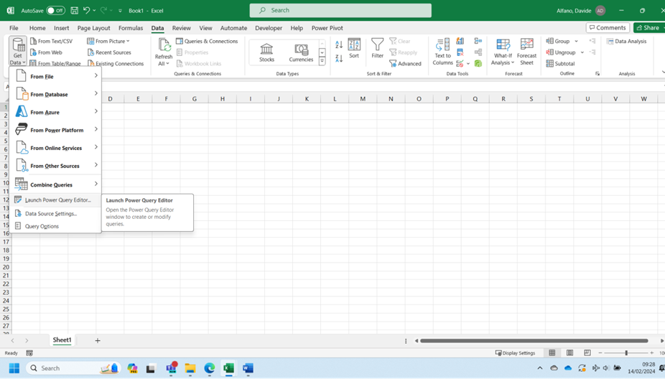
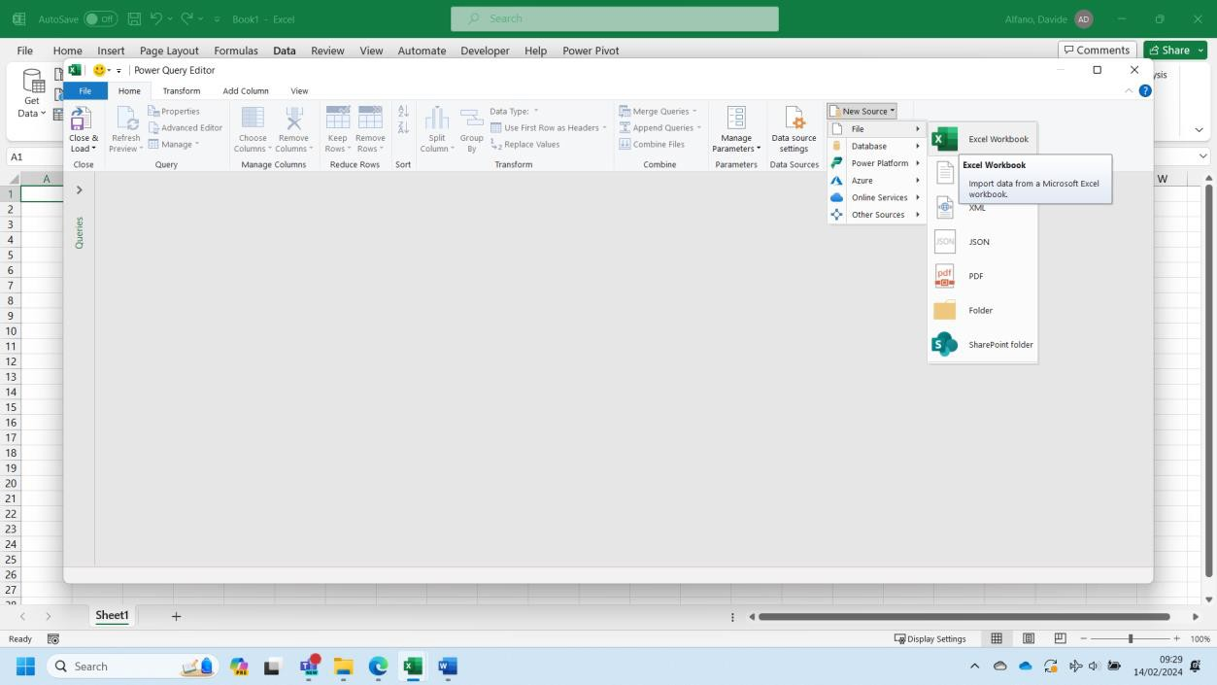

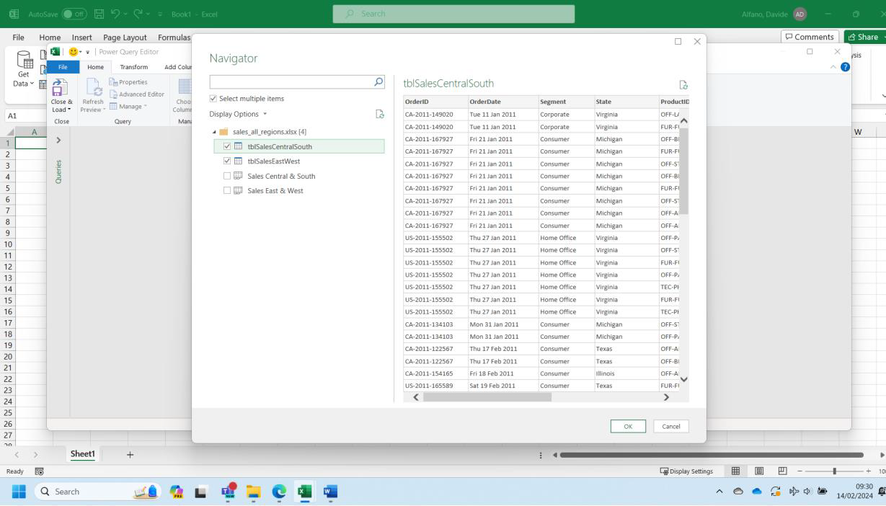

- How many rows are in SalesEW and in SalesCS? Use Count Rows under the tab Transform in Power Query Editor to get the information.
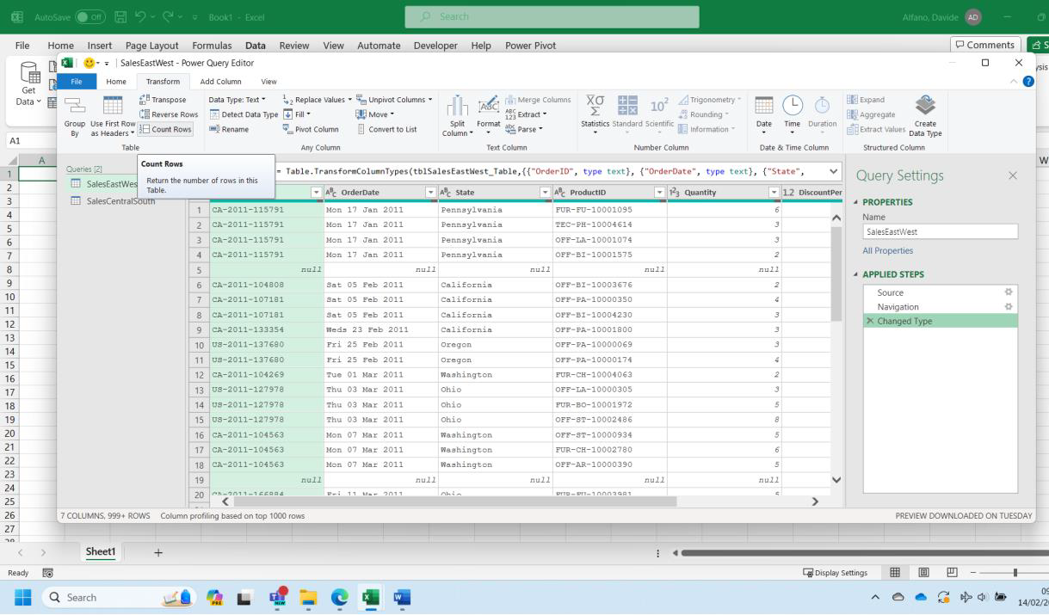
SalesEW: 1168
SalesCS: 762

- Remove the blank rows from SalesEW, SalesCS. How many blank rows are removed? Use Remove Blank Rows under Transform/Remove Rows to get the information required.
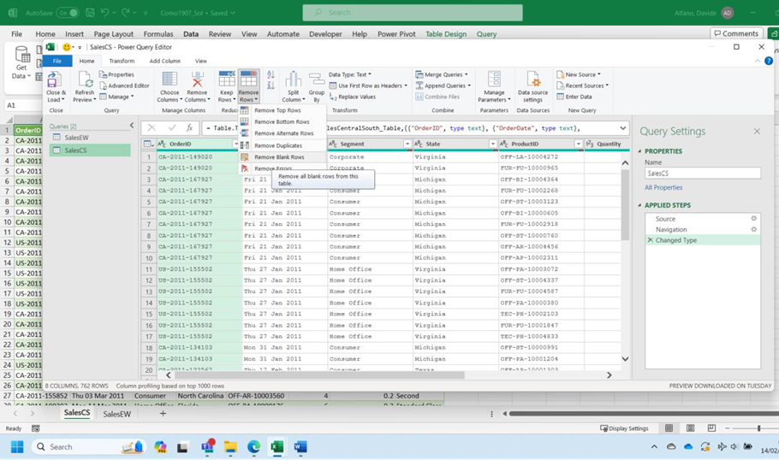
SalesEW: 25 (initial number of rows: 1168 - current number of rows: 1143)
SalesCS: 7 (762-755)

- Next, we need to append SalesCS to SalesEW. This means that we add the rows of SalesCS to the bottom of SalesEW. Let’s use Append Queries as New in Power Query Editor. The difference with Append Queries is that a new table is created because of it, without any change to the existing tables.
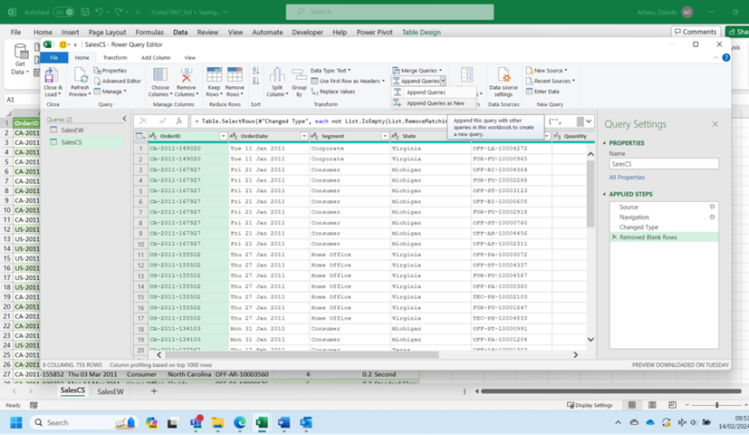
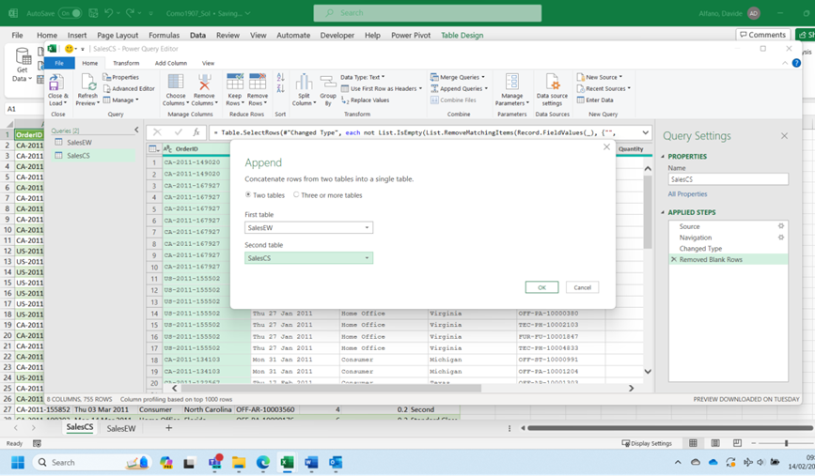

- Which column of SalesCS does not match with any column of SalesEW?
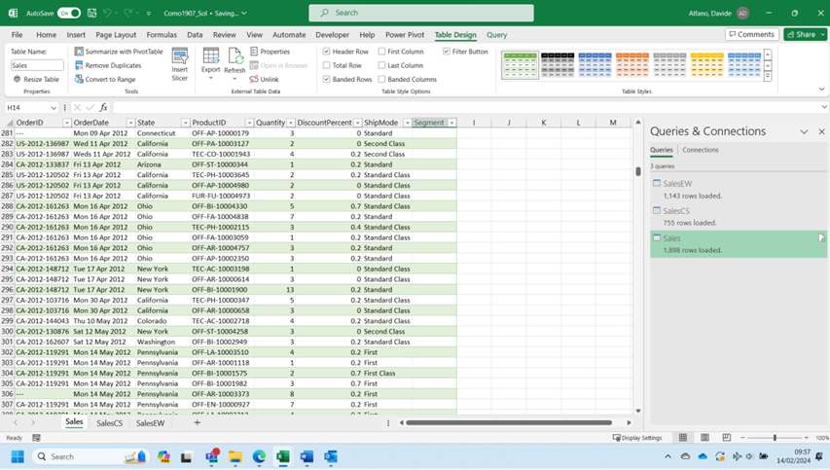

The only unmatched column between the two tables is segment. Delete it from Sales.

- Verify that Sales contains 7 columns and 1,898 rows, and that all columns were appended in the correct positions.
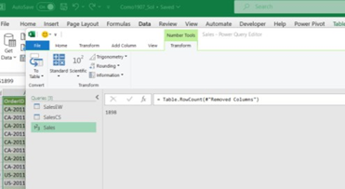

Part 2: Clean the Sales table
- Inspect the Sales table. Ensure that the [Quantity] column is formatted as an integer (whole number). Ensure that the [DiscountPercent] column has been correctly parsed as a numeric percentage (not just a string with "%" at the end).
We can easily modify the data type in Power Query Editor selecting the appropriate option on the left top corner of each column header.
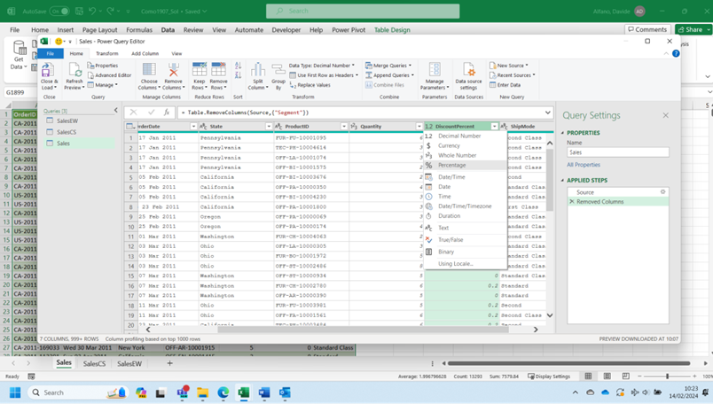

- In the [ShipMode] column, the values ‘First’, ‘Second’ and ‘Standard’ should instead be ‘First Class’, ‘Second Class’ and ‘Standard Class’. Make this correction.
Use Replace Values in Power Query Editor.
You will probably need to split the [ShipMode] column in two columns before, eliminating the word Class, where available, from the first column. The second column originating from the split will be dropped.
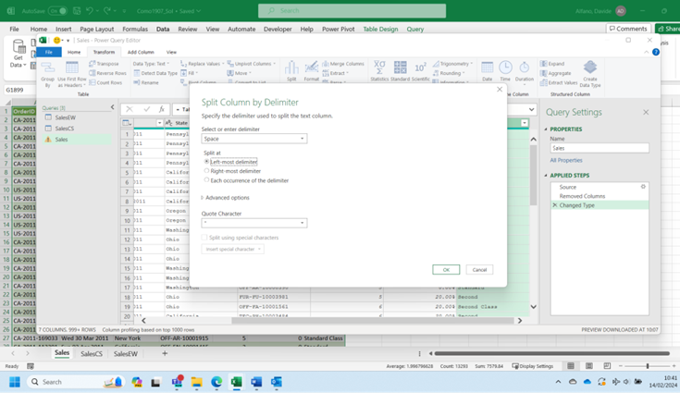
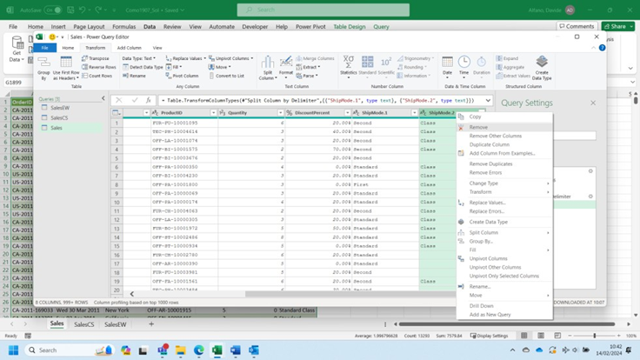

Now we can use Replace Values to replace First Class to First, Second Class to Class.
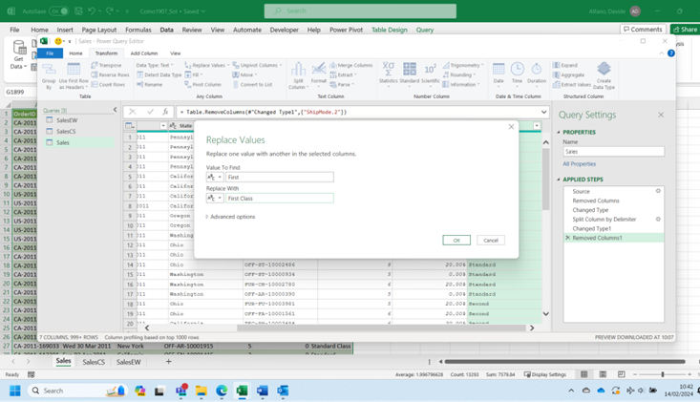
Because of the correction, the only distinct values in this column are now "First Class", "Second Class", "Standard Class" and "Same Day".
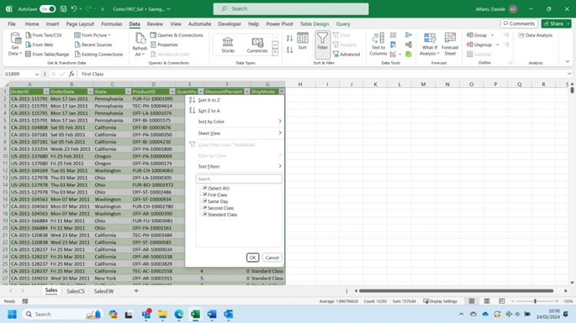
- The [OrderDate] column contains dates formatted as text. These values need to be converted to machine-readable dates. Perform this conversion.
If not all [OrderDate] values were successfully converted to dates, explain what the problem was. Fix the problem.
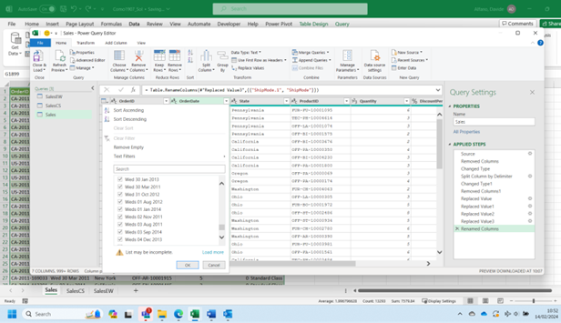

We can easily modify the data type in Power Query Editor, by selecting the appropriate option (Date) on the left top corner of the column header.
However, some records are unproperly using the abbreviation ‘Weds’ for Wednesday, instead of ‘Wed’. ‘Weds’ is not treated as a valid abbreviation for Wednesday by Power Query Editor when implementing the conversion of the field to Date. We must fix this replacing Weds with Wed using Replace Values. Afterwards, we can change the datatype as previously described.

Part 3: Analysis
- How many units were sold in total (sum of [Quantity])?
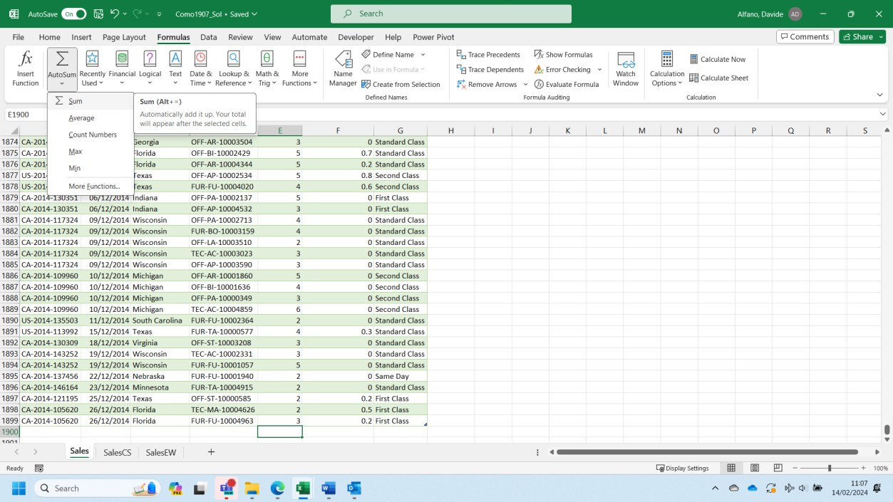
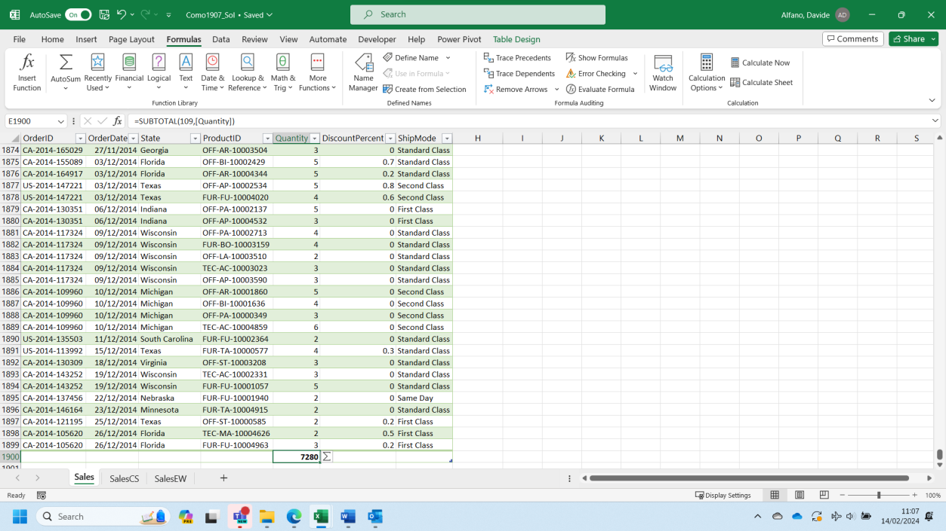

The AutoSum function (under the tab Formulas in Excel) gives us the result of 7280 units sold in total.

- Which state has purchased the most units? Which state has purchased the fewest units? A Pivot Table can help you in determining the total number of units sold in each state (‘sum of quantity’). Values will have to be re-ordered according to the ‘sum of quantity’.
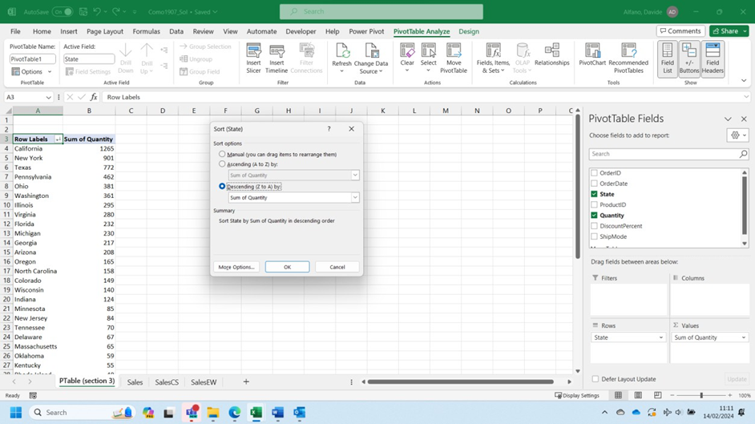
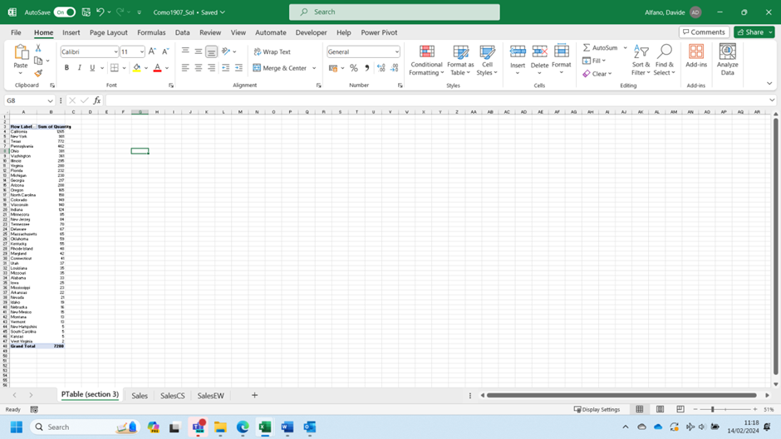

- What are the three most common [DiscountPercent] values? Once again, the best option is to use a Pivot Table as defined below:
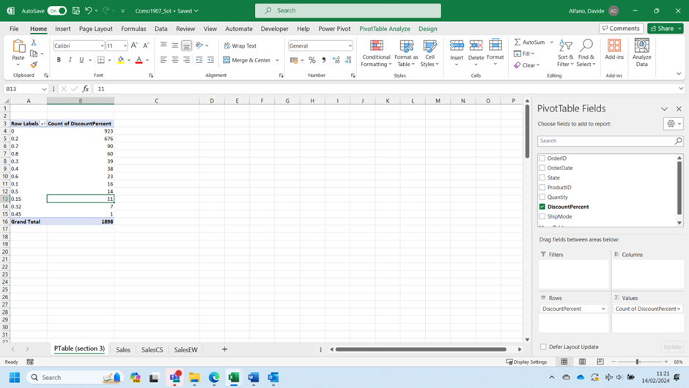

- How many units were shipped by each [ShipMode]? Plot a suitable chart. The Pivot Table that has been created will have to be re-designed as shown below. Based on the same Table, a Graph will be added to visualise the information required.
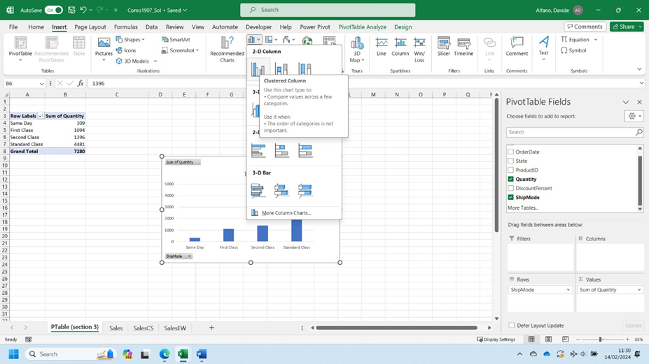
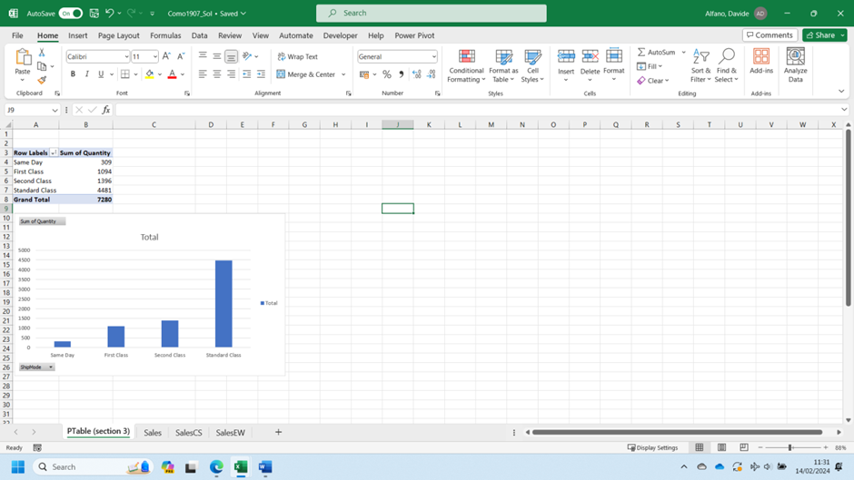

- How many units were shipped each year? Plot a suitable chart. Briefly describe the trend over time from 2011 to 2014. PivotTables can perform date aggregation by Year, Month, Day, for example. Right-click somewhere inside a date column of a PivotTable and select Group.
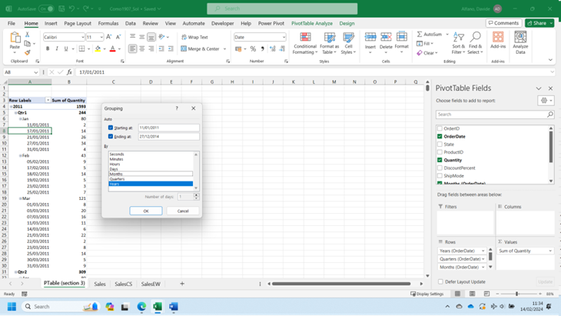
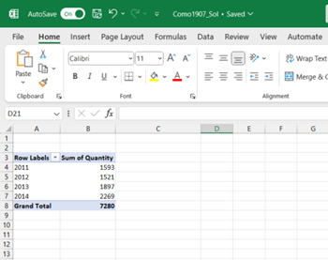

Part 4: Clean the Product Table
- Import this file. Name the table ‘Product’.
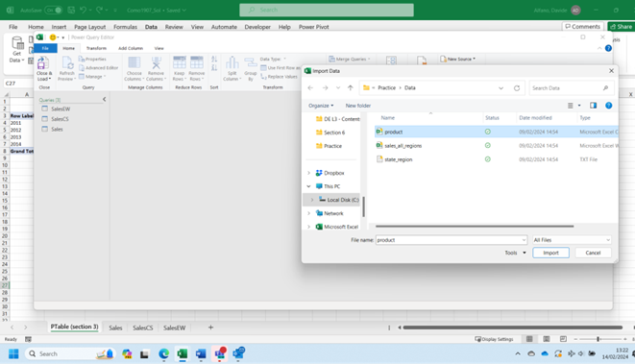

The first row will have to be promoted as header (Use First Row as Header under the Tab Home).
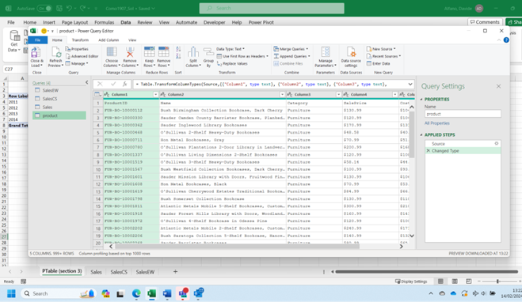

- The [SalePrice] and [CostPrice] columns need to be converted to a numeric type (Currency is a suitable type). Perform this conversion.
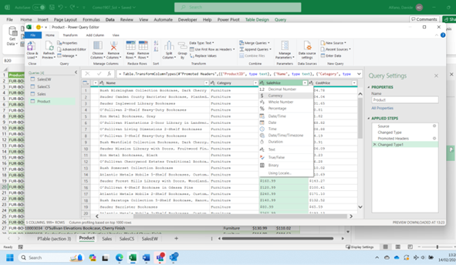

Literal ‘$’ character prevented conversion to a numeric type. Solution: replace ‘$’ with ‘ ’, (remove the ‘$’ symbol).
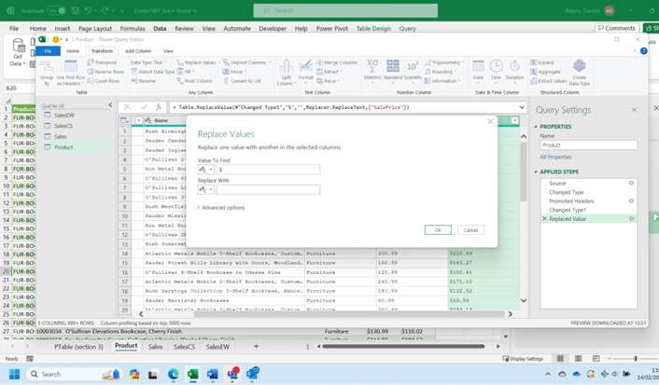

After this change the conversion to currency can be performed.
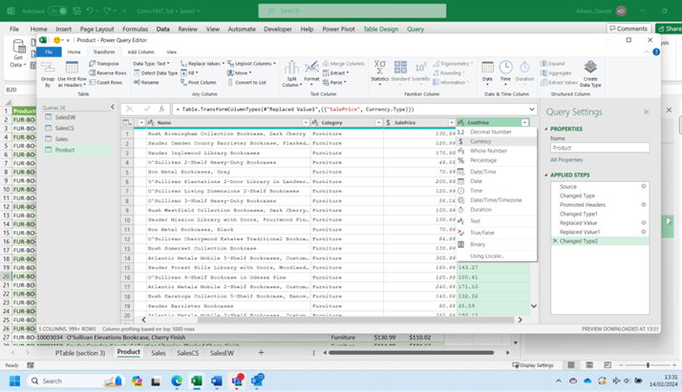
- Create a new column, [Markup], calculated as [SalePrice] – [CostPrice]. Round this column to two decimal places to eliminate minor rounding errors by converting it to an appropriate type.
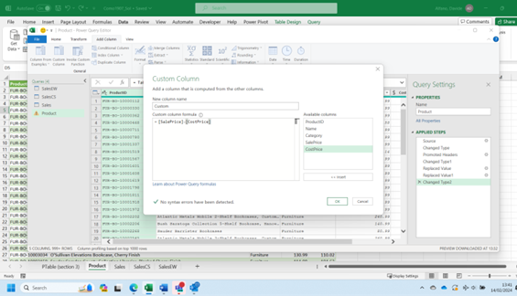
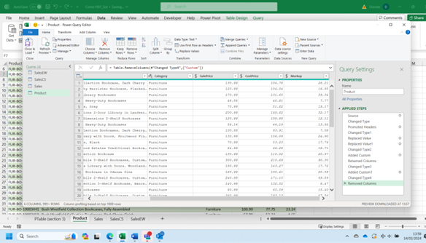

- Create a new column, [MarkupPercent], which expresses [Markup] as a fraction of [CostPrice]. A [MarkupPercent] of 0 (or 0%) means that [SalePrice] is equal to [CostPrice]. A [MarkupPercent] of 1 (or 100%) means that [SalePrice] is double [CostPrice]. Convert [MarkupPercent] to a suitable numeric type. It is not necessary to round this column.
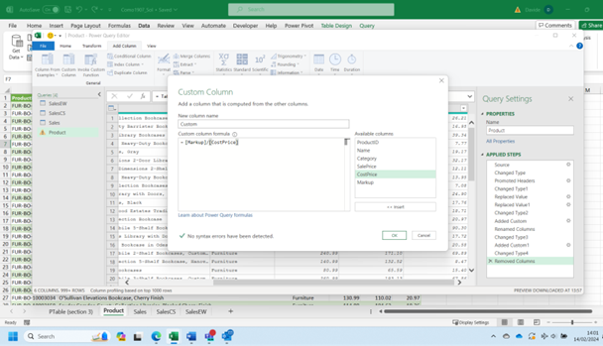
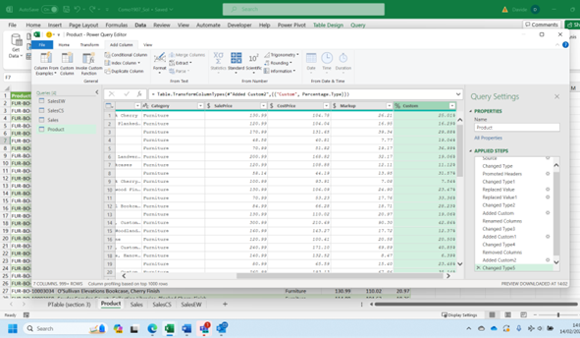

Part 5: Analysis
- What are the mean, median, and mode of [Markup] (in $)? Use the Excel formulas median(), MODE.SNGL(), average() to estimate those values.
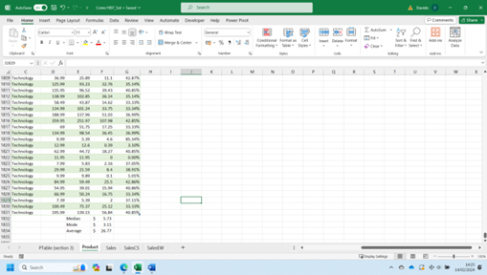

- Which product has the highest [Markup]? There are no ties. Apply appropriate number formatting. The first step requires to determine the highest Markup value. You can use the Excel function Max().
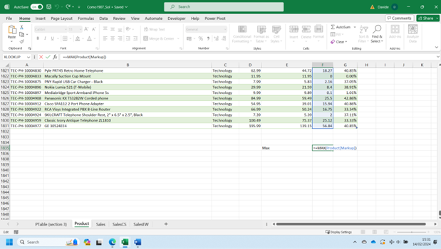

Secondly, you will have to find the corresponding product using the Xlookup () function.
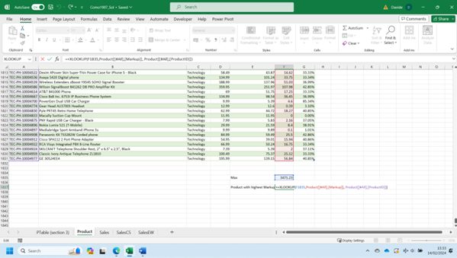

- Which product has the highest [MarkupPercent]? (There are no ties.) The steps to implement are the same as for the previous question. You only need to change the column of reference.
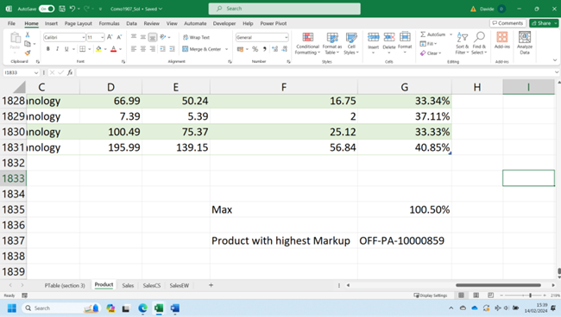
- What is the lowest [Markup], and how many products share it? Use the Excel function min() to determine the lowest Markup, and the function countif() to determine the number of products having the lowest Markup.
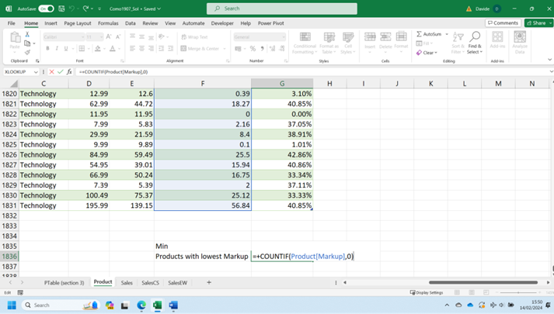

- Find the mean [Markup] and mean [MarkupPercent] by [Category]. Plot one or more suitable charts. Which [Category] has the highest mean [Markup]? Which [Category] has the highest mean [MarkupPercent]? A Pivot Table can help you in answering such a question in straightforward way.
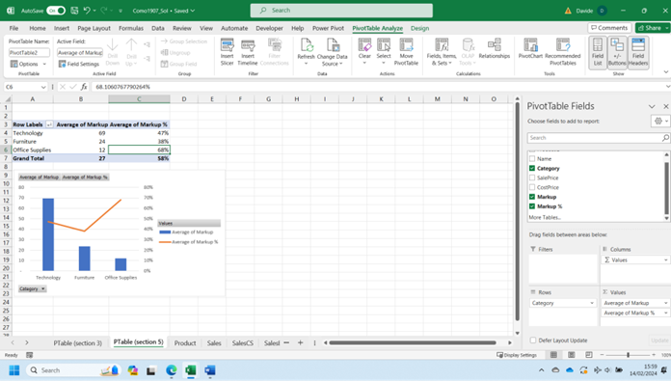

Activity: Scenario demonstration practice — Day 2

Part 6: Merge Sales to Product
- Create a new table by merging the Sales table to the Product table on an appropriate join column. Use a left join, with Sales as the left table. Name the new table ‘SalesDetails’.
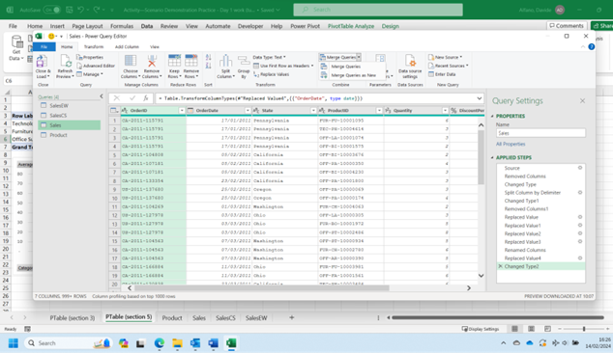
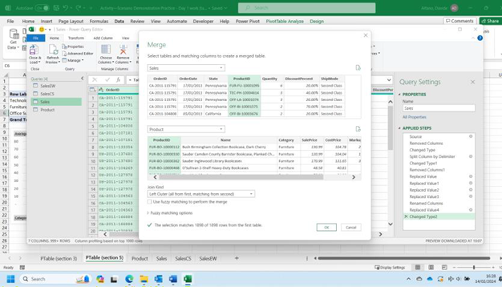
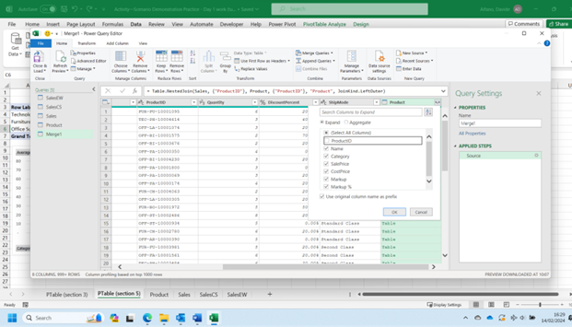

Total number of columns /rows: 13/1898
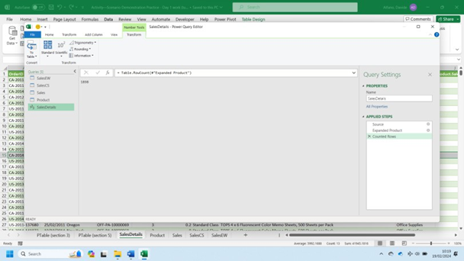

- In the SalesDetails table, rename the [SalePrice] column ‘UnitFullSalePrice’. This is the undiscounted sale price of a single unit of the product.

- Create a new column, [UnitDiscountedSalePrice], and populate it with the discounted sale price of a single unit of the product. Round this column to two decimal places to prevent invalid unit prices.
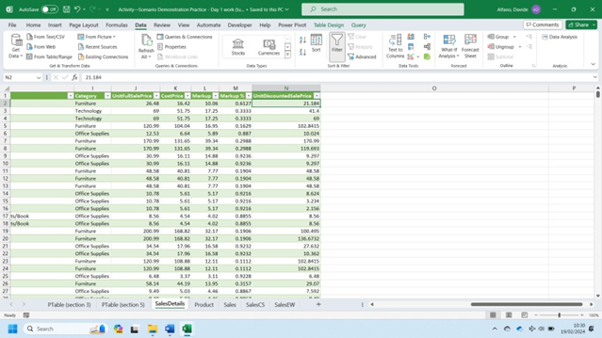

- Create a new column, [Sales], calculated as [UnitDiscountedSalePrice] × [Quantity].
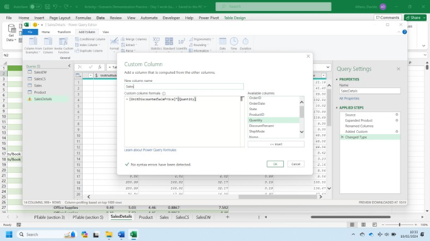

- Rename the [CostPrice] column ‘UnitCostPrice’. Create a new column, [TotalCost], calculated as [UnitCostPrice] × [Quantity]. Round and format this column as you deem appropriate.
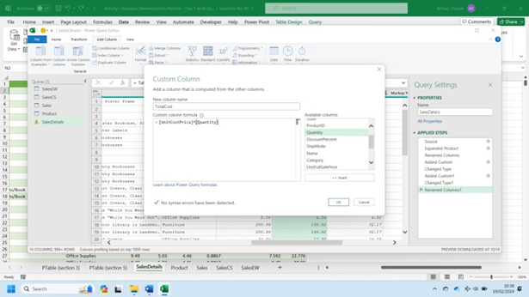

- Create a new column, [Profit], calculated as [Sales] – [TotalCost].
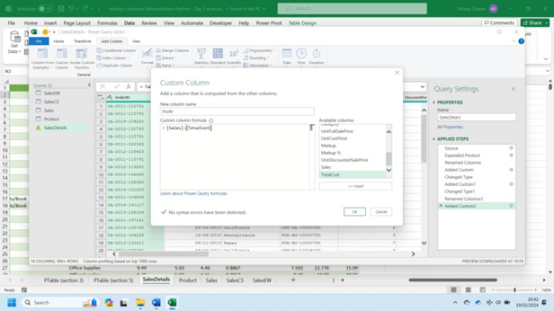
- Create a new column, [ProfitPerItem], and populate it appropriately. Round this column as you deem appropriate.
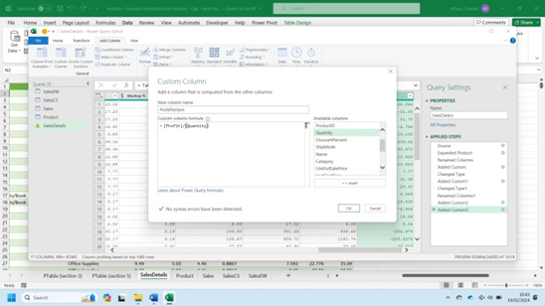

- Create a new column, [ProfitPercent], calculated as [ProfitPerItem] / [UnitCostPrice].
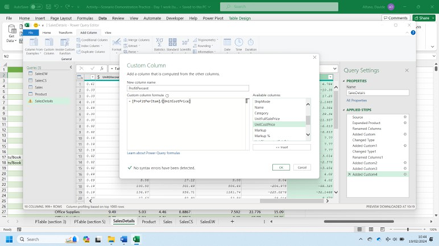

Part 7: Analysis
- Calculate the sum of [TotalCost], the sum of [Sales], and the sum of [Profit]. A possible way to determine the same is using the function Autosum() in Excel under the tab Formulas.
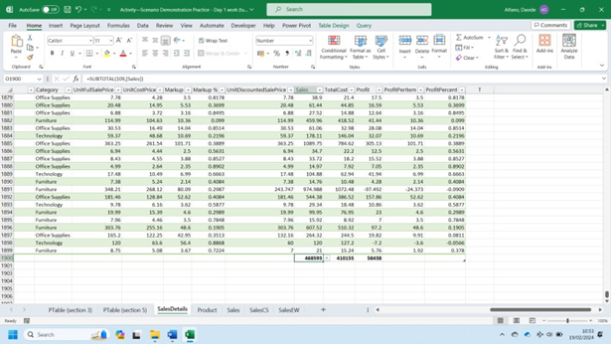

- Verify that sum of [Profit] is equal to sum of [Sales]– sum of [TotalCost] as estimated before through the Autosum function.
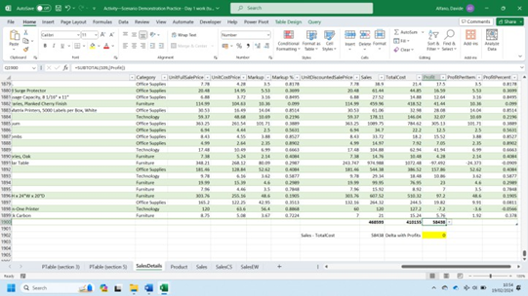

- In which month of the year is the mean [DiscountPercent] highest? You can use a Pivot Table to estimate the required information, as shown below:
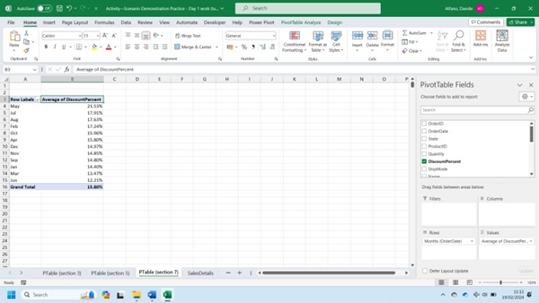

- In which month of the year is the mean [ProfitPercent] highest? Again, a Pivot Table as shown below will help you answering the question.
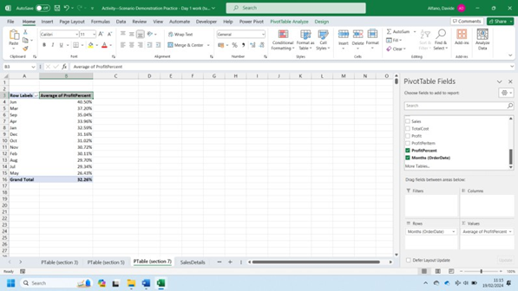

- If you were to plot the mean [ProfitPercent] vs. [DiscountPercent], what do you predict the trend would look like?
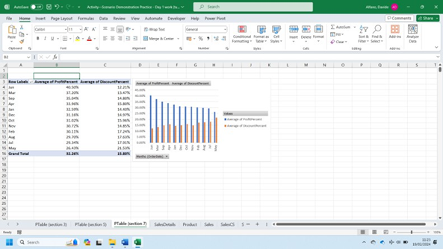

Using the average monthly values estimated earlier, the highest the applied discount the lowest will be the profit.

- Calculate the mean [ProfitPercent] for each distinct value of [DiscountPercent]. Plot a suitable chart. Briefly describe the trend.
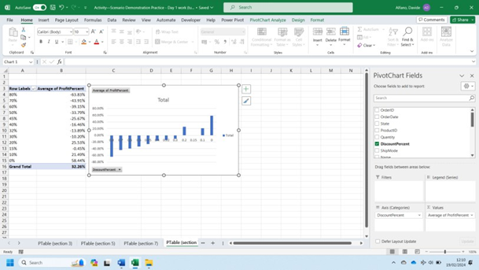

Again, the evidence is that the highest the applied discount, the lowest will be the average profit obtained.

- For each [State], calculate the sum of [Quantity] and the sum of [Profit]. A Pivot Table as shown below may help in visualising the required information
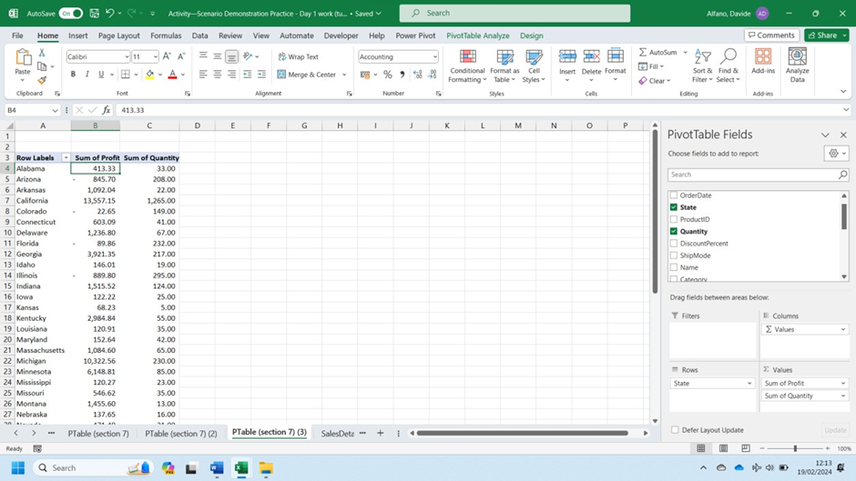

- How many [State]s have a negative sum of [Profit]? Appropriately filtering the Pivot Table, as defined below, you will determine the states which have a total profit below zero.
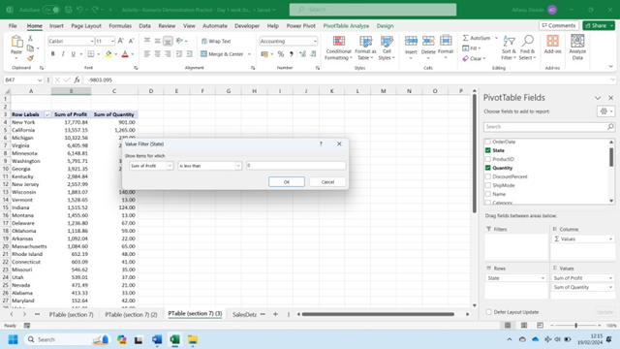
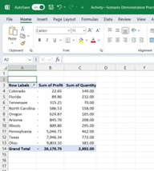

- For each [State], calculate (sum of [Profit]) / (sum of [Quantity]) to obtain the mean profit per item for that [State]. What are the top three [State]s by mean profit per item?
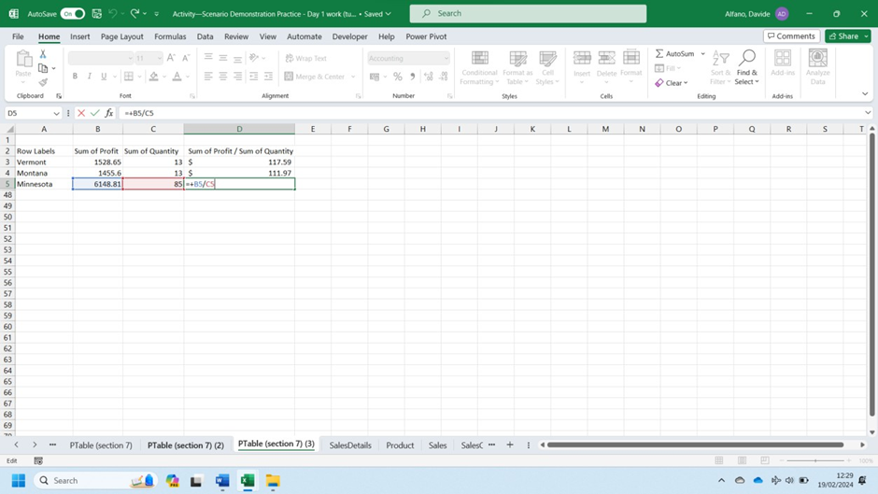

Part 8
- In the ‘data’ folder, locate the tab-delimited text file ‘state_region.txt’. Import this file. Name the table ‘StateRegion’.
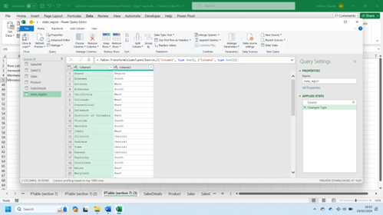

- Find and correct the misspelling in the [Region] column. Verify that the only distinct regions are now ‘East’, ‘West’, ‘Central’, and ‘South’. Firstly, select the first row as header:
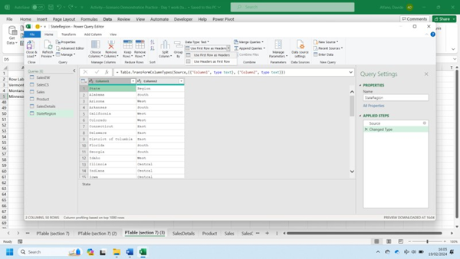

The word central has been misspelt. Use replace values to fix this:
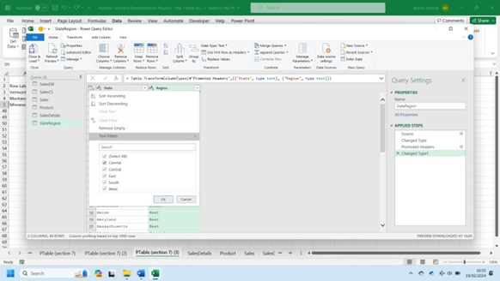
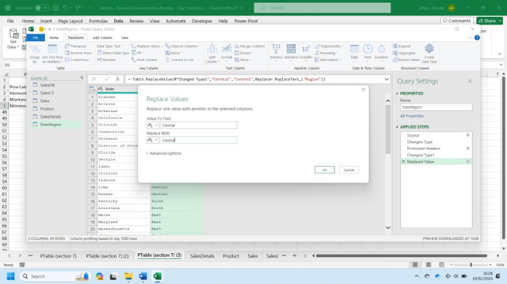

- Modify the SalesDetails table by merging the StateRegion table to it on a suitable join column. Use a left join. Bring in only the [Region] column from the StateRegion table.
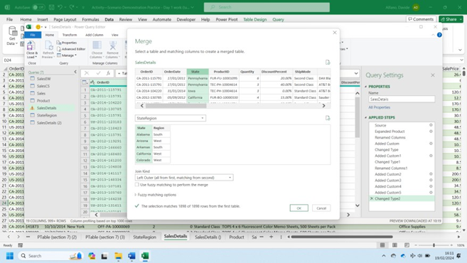
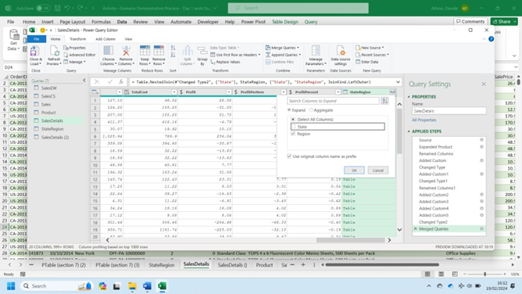

- Finally, save the SalesDetails table in the following formats: CSV, Text, Excel workbook.

Part 9: Analysis
- Calculate the total [Profit] by [Region] and [Category].
For which combination of {[Region], [Category]} is total [Profit] highest?
For which {[Region], [Category]} is total [Profit] negative?
You may refer to the following Pivot Table to identify the answers to both questions:
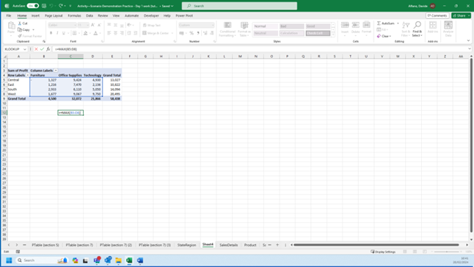

West: Technology
Central: Furniture

- Calculate the sum of [Quantity] by [Region] and [ShipMode]. Display the sums as a percentage of the total [Quantity] for each [Region].
In which [Region] is the percentage of items delivered First Class higher than the percentage of items delivered Second Class?
Firstly, let’s create a Pivot Table with the appropriate fields:
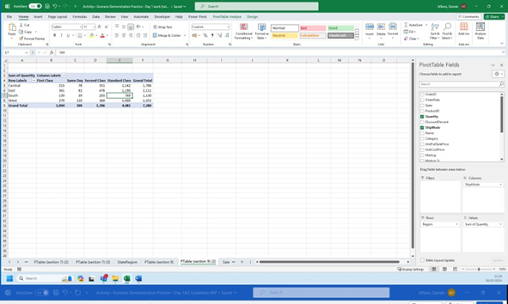

Then, display the values as percentage of row values:
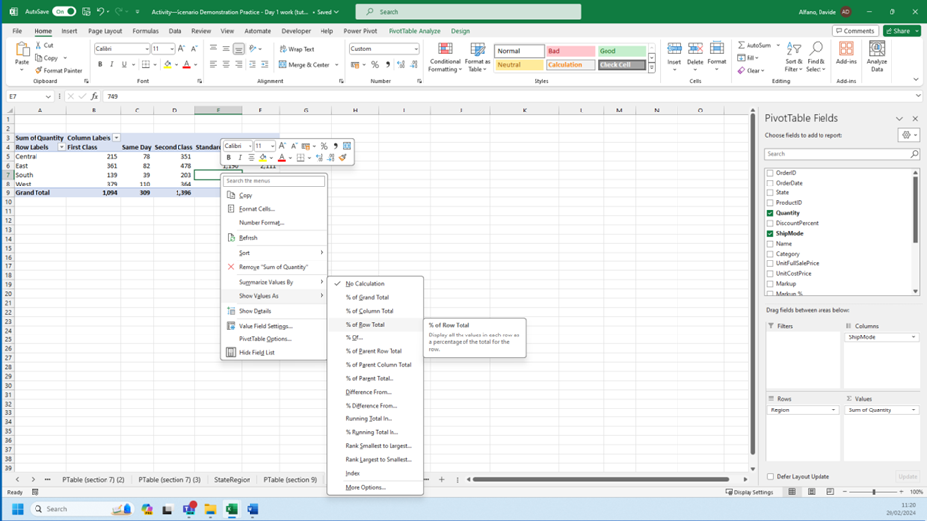

West is the only region where the percentage of First Class Shipping is higher than Second Class Shipping.

Challenge
- Find the product with the highest [UnitFullSalePrice] within the [Category] with the lowest sum of [Sales] within the [Region] with the second highest number of [State]s.
Firstly, define which is the region with the second highest number of states creating a pivot table based on StateRegion:
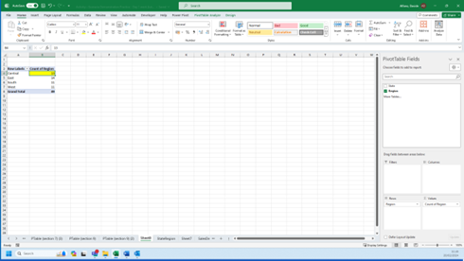

- Secondly, within Central Region, let’s define the Category with the lowest sum of Sales using a pivot table based on SalesDetails:
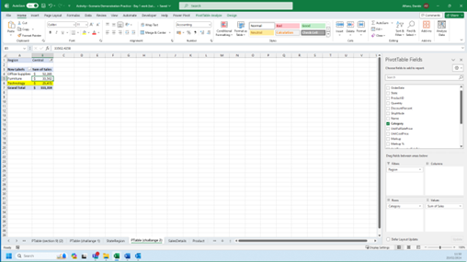

- Let’s now find the product with the highest UnitFullSalePrice within the Technology category.
